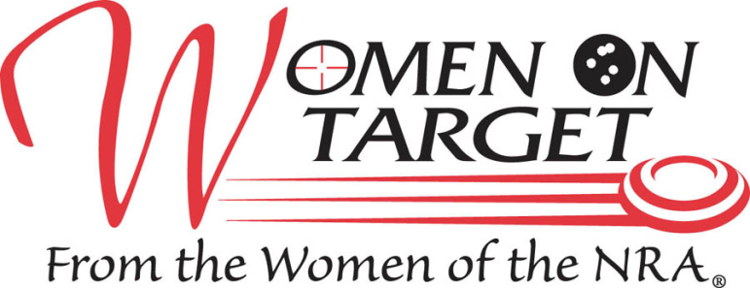

LADIES ONLY INSTRUCTIONAL SHOOTING CLINIC

16 years or older

This clinic is for women with little or no shooting experience.

RIFLE * PISTOL * SHOTGUN * ARCHERY

Firearms, Ammunition, Targets, Eye and Ear Protection, Light Breakfast and Lunch are provided

**JUNE 1st, 2013 from 8:30 A.M. – 5:00 P.M. @**



**8640 Moon Rd. Saline, MI 48176**

ADVANCE PAYMENT, WAIVERS AND REGISTRATION REQUIRED

$75.00

For more information contact Renee or Sarah Tellas (734)439-1363 or email: [tcslwot@yahoo.com](mailto:tcslwot@yahoo.com)

Complete below, read and sign waiver on back of form.

Last name:____________________________ First name:____________________________

Address:___________________________ City:______________ State:____ Zip:_________

Phone:____________________ E-mail:___________________________________________

I have… ⬜ never shot before , or only once or twice ⬜ some shooting experience

Group Registration ⬜ If yes, please List group member’s names: ________________

___________________________________________________________________________

Unisex T-shirt size: ⬜ X-Small ⬜ Small ⬜ Medium ⬜ Large ⬜ X-Large ⬜ 2X

This Application cannot be accepted without your signature for the waiver on the back of this page.

Send advanced registration and check (payable to TCSL) before June 1, 2013 to:

Women On Target®

Attn: Sarah Tellas

3121 Judd Rd.

Milan, MI 48160

**RELEASE, WAIVER, INDEMNIFICATION, HOLD HARMLESS, AND ASSUMPTION OF THE RISK AGREEMENT AND PERMISSION FOR PHOTOGRAPHY**

In consideration of being permitted to attend a course for instruction in firearms, for the instruction in firearms, for use of the range, ant building, or land (collectively described as “the instructional site”), and for other good and valuable consideration, the receipt and sufficiency of which is hereby acknowledged, the undersigned STUDENT agrees to each of the following:

STUDENT agrees to **indemnify, hold harmless and defend** Lorena Tellas, Sarah Tellas, Jim Pryce, Charles Tellas, Tri-County Sportsmen’s League, and any instructor, volunteer or appointee assisting with any activity associated with Women On Target and Tri-County Sportsmen’s League (hereinafter referred to individually or collectively as “INSTRUCTOR”), from any and all fault, liabilities, costs, expenses, claims, demands, or lawsuits arising out of, related to, or connected with any of the following: STUDENT’s presence at and/or participation in, the course of instruction; the discharge of firearms by STUDENT; STUDENT’s presence on or use of the instructional site; and, any and all acts or omissions of STUDENT.

Furthermore, STUDENT **waives** for him/herself and for his/her personal representatives, assignees, next of kin and heirs, any and all rights and claims for damages, losses, demands and any other actions or claims whatsoever, which he/she may have or which may arise against INSTRUCTOR (including, but not limited to, the death of STUDENT and/or any and all personal injury or illness, or other personal damages or property damages (of whatever nature) suffered by STUDENT or STUDENT’s property), which may in any way whatsoever, arise out of, be related to or be connected with: the course of instruction or the instructional site; STUDENT’s property (whether or not entrusted to INSTRUCTOR); and the discharge of firearms. INSTRUCTOR shall not be liable for, and STUDENT, on behalf of him/herself and on behalf of his/her personal representatives, assignees, next of kin, and heirs, hereby **expressly releases**, the INSTRUCTOR(s) from any and all such claims and liabilities.

STUDENT hereby **expressly assumes** the risk of taking part in the course for instruction in firearms and taking part in the activities on the instructional site, which include (but are not limited to) instruction in the use of firearms, the discharge of firearms and the firing of live ammunition.

STUDENT hereby acknowledge and agrees that said **STUDENT has read this agreement, understands its terms and is executing this instrument voluntarily.** STUDENT furthermore hereby acknowledges and agrees that he/she has read, understands and will at all times abide by all range rules and procedures and any other rules and procedures stated by the INSTRUCTOR.

STUDENT expressly agrees that this instrument is intended to be as broad and inclusive as permitted by law and that if any provision of this agreement is held invalid or otherwise unenforceable; the enforceability of the remaining provisions shall not be impaired thereby. No remedy conferred by any of the specific provisions of this agreement is intended to be exclusive of any other remedy, and each and every remedy shall be cumulative, and shall be in addition to every other remedy now, or hereafter existing at law or in equity or by statute or otherwise. The election of any one o more remedies by the INSTRUCTOR to enforce the INSTRUCTOR(s) rights under this agreement shall not constitute any waiver of INSTRUCTOR(s) right to pursue other available remedies. This agreement binds STUDENT and his/her personal representatives, assignees, next of kin and heirs. Should INSTRUCTOR employ any attorney, or incur any expenses or economic loss, in order to defend and enforce INSTRUCTOR(s) rights and remedies established by the terms of this agreement, STUDENT shall be liable to INSTRUCTOR for all of the INSTRUCTOR’s actual and reasonable attorney fees and expenses, and shall pay and make the INSTRUCTOR whole for any economic loss sustained.

For valuable consideration received, I grant to Tri-County Sportsmen’s League and NRA Women On Target ("Photographers") the absolute and irrevocable right and unrestricted permission concerning any photographs that he/she may take of me or in which I may be included with others, to use, reuse, publish, and republish the photographs in whole or in part, individually or in connection with other material, in any and all media now or hereafter known, including the internet, and for any purpose whatsoever, specifically including illustration, promotion, art, editorial, advertising, and trade, without restriction as to alteration; and to use my name in connection with any use if he/she so chooses. I release and discharge Photographers from any and all claims and demands that may arise out of or in connection with the use of the photographs, including without limitation any and all claims for libel or violation of any right of publicity or privacy. This authorization and release shall also inure to the benefit of the heirs, legal representatives, licensees, and assigns of Photographers, as well as the person(s) for whom he/she took the photographs. I am a legally competent adult and have the right to contract in my own name. I have read this document and fully understand its contents. This release shall be binding upon me and my heirs, legal representatives, and assigns.

_______________________________________ _______________________________________ _____________________

Signature of STUDENT Printed name of STUDENT DATE

Relied upon and accepted by: _________________________________________________________ _____________________

INSTRUCTOR signature DATE